# Documentation for Setting Up VirtualBox and Virtual Machine

1. Download VirtualBox =

Download Virtualbox on a web browser from the official Virtualbox website.

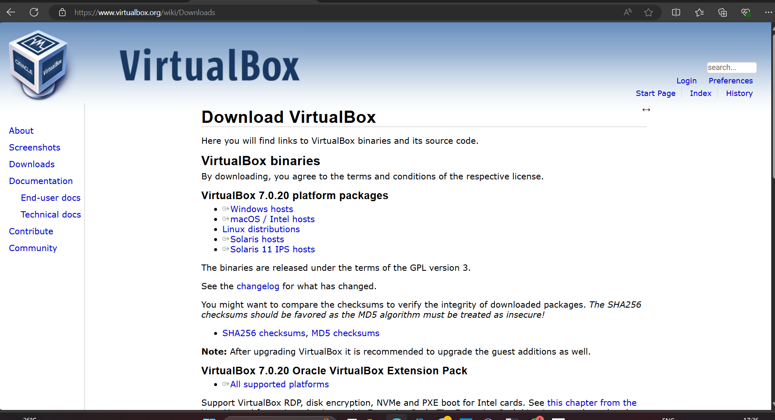

1. Post-installation Configuration =

**Group Permissions:**

* Ensure the user account is added to the "VirtualBox Users" group to manage VMs effectively.

**Reboot or Log Out/In:**

* After modifying group memberships, it's a good practice to either reboot the machine or log out and log back in to apply changes.

1. Setting Up a Virtual Machine with Ubuntu 22.04 =

**Download Ubuntu 22.04:**

* Visit [osboxes.org](https://www.osboxes.org/) and download the Ubuntu 22.04 image file.

**Create a New Virtual Machine in VirtualBox:**

Created a virtual machine named “UbuntuMymachine” on Virtual Box.

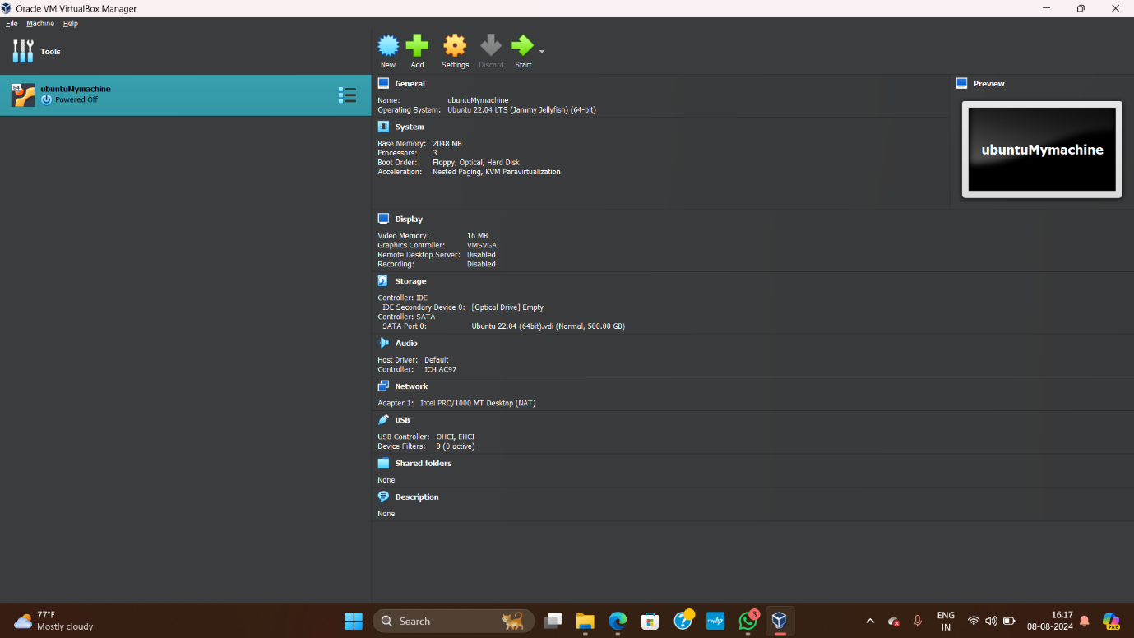

**Install Nginx:**

Start the VM and install Nginx inside Ubuntu.

“sudo apt update”

“sudo apt install nginx”

Configure Nginx to serve a simple HTML page.

1. Network Scanning with Nmap =

